Chicken Boneless

The Chicken Boneless game is in the genre of shooting arcade, an endless game making high scores. After loading the game, the first scene is the main menu, allowing players to check the high score record or enter the game. When the player enters the game, the first scene is the player being a chicken that can control movement in 8 directions: up, down, left, right, up-left, upright, down-left, and down-right.

The chicken will spawn in the center of the screen, and the enemy will show up with different enemies. The game has three enemies: a dog, a cat, and a human. Dogs and cats will run in the game at various speeds and directions, but humans will run at slower speeds than dogs and cats, but the direction is focused on the chicken.

The player has the bone as a weapon to shoot the enemy to collect points. The game will run as an endless game, where the player has to escape catching the enemy by using movement in all eight directions and using the bone to destroy the enemy.

Once the enemy catches the chicken, the game ends, and the chicken turns into Chicken Boneless.

Author: Teerapath Keawratana

Date: 15/01/2025

Copyright Information

**Document Revision history:**

|  |  |  |  |
| --- | --- | --- | --- |
| Version | Date | Author(s) | Changes |
| 0.1 | January 15, 2025 | Teerapath Keawratana |  |
|  |  |  |  |
|  |  |  |  |

Table of Contents

1. Section I - Game Overview 7

1.1. Game Concept 7

1.2. Design History 7

1.3. Feature Set 7

1.4. Genre 7

1.5. Target Audience 7

1.6. Game Flow Summary 7

1.7. Look and Feel 7

1.8. Project Scope 7

1.8.1. Number of locations 7

1.8.2. Number of levels 7

1.8.3. Number of NPC’s 7

1.8.4. Number of weapons 7

1.8.5. Etc. 7

2. Section II - Gameplay and Mechanics 7

2.1. Gameplay 7

2.1.1. Game Progression 7

2.1.2. Mission/challenge Structure 7

2.1.3. Puzzle Structure 8

2.1.4. Objectives – What are the objectives of the game? 8

2.1.5. Play Flow – How does the game flow for the game player 8

2.2. Mechanics 8

2.2.1. Physics 8

2.2.2. Movement 8

2.2.3. Objects 8

2.2.4. Actions 8

2.2.5. Combat 8

2.2.6. Economy 8

2.3. Screen Flow 8

2.3.1. Screen Flow Chart 8

2.3.2. Screen Descriptions 8

2.4. Game Options 9

2.5. Replaying and Saving 9

2.6. Cheats and Easter Eggs 9

3. Section III – Story, Setting and Character 9

3.1. Story and Narrative 9

3.1.1. Back story 9

3.1.2. Plot Elements 9

3.1.3. Game Progression 9

3.1.4. License Considerations 9

3.1.5. Cut Scenes 9

3.2. Game World 9

3.2.1. General look and feel of world 9

3.2.2. Area #1 10

3.2.3. Area #2 10

3.3. Characters 10

3.3.1. Character #1 10

3.3.2. Character #2 10

4. Section IV – Levels 10

4.1. Level #1 10

4.1.1. Synopsis 10

4.1.2. Introductory Material (Cut scene? Mission briefing?) 10

4.1.3. Objectives 10

4.1.4. Physical Description 11

4.1.5. Map 11

4.1.6. Critical Path 11

4.1.7. Encounters 11

4.1.8. Level Walkthrough 11

4.1.9. Closing Material 11

4.2. Level #2 11

4.3. Training Level 11

5. Section V - Interface 11

5.1. Visual System 11

5.1.1. HUD - What controls 11

5.1.2. Menus 11

5.1.3. Rendering System 11

5.1.4. Camera 11

5.1.5. Lighting Models 11

5.2. Control System 11

5.3. Audio 11

5.4. Music 11

5.5. Sound Effects 11

5.6. Help System 11

6. Section VI - Artificial Intelligence 11

6.1. Opponent AI 11

6.2. Enemy AI 12

6.3. Non-combat Characters 12

6.4. Friendly Characters 12

6.5. Support AI 12

6.5.1. Player and Collision Detection 12

6.5.2. Pathfinding 12

7. Section VII – Technical 12

7.1. Target Hardware and operating system 12

7.2. Supported game controllers and peripherals 12

8. Section VIII – Game Art 12

8.1. Concept Art 12

8.2. Style Guides 12

8.3. Characters 12

8.4. Environments 12

8.5. Equipment 12

8.6. Cut scenes 12

8.7. Miscellaneous 12

# Section I - Game Overview

## Game Concept

The concept of this game is from a restaurant that has a promotion for All-you-can-eat Chicken Boneless, many customers would like to eat chicken boneless. That would be an idea to create this game with the main actor as chickens have to escape from all enemies (dogs, cats, and humans). The chicken's weapon is bone, which is thrown to eliminate the enemy. When the chicken was caught, it would turn to be chicken boneless, and the game would end.

The chicken boneless game makes the player emotional because the chicken boneless game has a high score record, which makes players want to keep their name on the top of the recording and makes them always keep breaking the record, or if the other player can break their high score, it makes the player want to bring that position back.

## Design History

This is a living document and will change as you develop your game. This section maintains a history of any significant changes to your game.

Design background of menu scene, leaderboard background scene, and gaming background scene.

Design character of the chicken, bone, dog, cat, and human.

## Feature Set

The high score tracking is one of the features set in the game to make players feel more attracted and challenge them to keep their name on the leaderboard.

## Genre

Arcade, Shooting game.

## Target Audience

Casual Gamer, Competitive Players.

## Game Flow Summary

How does the player move through the game? Both through framing interface and the game itself.

The player can control a chicken by using the arrow on the keyboard or ASWD to control left, down, up, and right. Use a mouse to shoot the bone to the enemy.

## Look and Feel

The game is a 2D game, making the background of the game in the restaurant, and the player feels like the chicken is running away in the restaurant and doesn’t want to be a boneless chicken.

## Project Scope

The chicken boneless game is a 2D shooting arcade game with a high-score leaderboard.

### Number of locations

One location in the restaurant.

### Number of levels

There is no level exactly, but when players play the games longer, the games will spawn more enemy

### Number of NPC’s

There are three Non-Playable Characters.

The dogs will run in-game at a normal speed but with no direction.

The cats will run in-game faster than the dogs with no direction.

The humans will run at the slowest speed with a direction focused on the chicken.

### Number of weapons

One weapon that the chicken uses to destroy an enemy is chicken bone.

### Etc.

# Section II - Gameplay and Mechanics

## Gameplay

### Game Progression

When the game starts, the player controls a chicken to escape from an enemy(dogs, cats, and humans). Then, the player can shoot bones to destroy an enemy and collect a score. The game will spawn more energy when the player gets a higher score.

### Mission/challenge Structure

The game's mission is for the player to control a chicken to escape from dogs, cats, and humans that appear in the game. They must shoot them with a chicken bone to collect more scores and keep their name on the leaderboard.

### Puzzle Structure

No puzzle structure

### Objectives – What are the objectives of the game?

Keep chicken survival as long as possible and earn as much score as possible.

### Play Flow – How does the game flow for the game player

The player can control a chicken in the game to escape an enemy and shoot an enemy to keep a higher score.

## Mechanics

What are the rules to the game, both implicit and explicit. This is the model of the universe that the game works under. Think of it as a simulation of a world, how do all the pieces interact? This actually can be a very large section.

In the game, everything has to stay within the window frame. If an enemy hits the edge of the window, an enemy will reflect in the opposite direction at the same speed. For the chicken, if the player controls a chicken to hit the edge of the window, the chicken would be stopped at that position.

### Physics

How does the physical universe work?

The enemy's speed is constant, but the direction would change to the opposite direction after the enemy collapses with the edge of the window.

### Movement

#### General Movement

The player can use an arrow on the keyboard to move or use A-left, S-down, E-up, and D-right. And use the mouse to click left to shoot the bone weapon.

#### Other Movement

The dog and cat will move at a constant speed in a random direction. The human will move slower, but the direction follows the chicken.

### Objects

#### Picking Up Objects

#### Moving Objects

### Actions

#### Switches and Buttons

#### Picking Up, Carrying and Dropping

#### Talking

#### Reading

### Combat

If there is combat or even conflict, how is this specifically modeled?

### Economy

What is the economy of the game? How does it work?

## Screen Flow

### Screen Flow Chart

A graphical description of how each screen is related to every other.

Leaderboard Screen

Main Menu Screen

High Score Input Screen

Game Screen

High score?

### Screen Descriptions

What is the purpose of each screen?

The Main Menu Screen allows the player to choose to see the leaderboard screen or start the game on the game screen. If the player goes to the leaderboard Screen, they can only return to the Main Menu Screen.

When the player goes to play the game on the Game Screen and loses the game without reaching the high score, the game screen will return to the Main Menu Screen. But if the score reached a high score, the High Score Input Screen would appear to make the player input their name. After the player finishes inputting the name, it will go to the Leaderboard Screen and back to the Main Menu Screen again.

#### Main Menu Screen

The Main Menu Screen is like the home screen that the player has to return to every time after playing or watching the leaderboard.

#### Options Screen

The Game Screen is the scene where the player plays the game and has fun with the chicken boneless game.

The High Score Input would be shown to the player only when the player finished the game with a high score.

The Leaderboard Screen is used to show the player to watch the high score ranking, and only go back to the Main Menu Screen.

#### Etc.

## Game Options

What are the options and how do they affect game play and mechanics?

## Replaying and Saving

## Cheats and Easter Eggs

# Section III – Story, Setting and Character

## Story and Narrative

Specific details like scripts and cut scenes may not be in this document but be in the Story Bible.

### Back story

Start at the restaurant that cooks boneless chicken, but it has one lucky chicken try to escape from that restaurant. It’s trying to run away from dogs, cats, and humans, and they are trying to catch it.

### Plot Elements

### Game Progression

When the player plays the game longer, the game will make more enemies on the screen to challenge the player.

### License Considerations

The background picture of the Game, Main Menu, and Leaderboard Screen. The Sprite of a chicken, dog, cat, and human are license considerations.

### Cut Scenes

#### Cut scene #1

At loading the game, in the Main Menu Screen

##### Actors

A Chicken

##### Description

A Chicken smiling and happy like it already escaped from the restaurant.

##### Storyboard

A chicken had already run away from the kitchen at the restaurant and thought it was safe, but unfortunately, it was still in the dining room, so the chicken had to run away again.

##### Script

#### Cut scene #2

At the end of the game, after a chicken was caught.

##### Actors

A chicken

##### Description

A chicken was caught and turned into a chicken boneless.

##### 3.1.5.2.3 Storyboard

At the end of the game, the chicken is caught by the enemy and turned into a chicken boneless in the restaurant.

## Game World

### General look and feel of world

### Area #1

The background of the game screen

#### General Description

The background of the game screen is in the dining room at the restaurant.

#### Physical Characteristics

The dining room at the restaurant that are clean and a little bit darkness.

#### Levels that use area

#### Connections to other areas

### Area #2

etc.

## Characters

### Character #1

A Chicken

#### Back story

A chicken ran away from the kitchen at the restaurant, thinking it was safe, but unfortunately, it was still in the dining room.

#### Personality

A happy chicken, but easy to panic.

#### Look

##### Physical characteristics

##### Animations

#### Special Abilities

A chicken can use bone as a weapon.

#### Relevance to game story

The main actor in the game.

#### Relationship to other characters

#### Statistics

### Character #2

A dog in the dining room

#### Back story

A dog runs into the dining room because it sees the chicken and wants to eat a boneless chicken.

#### Personality

Hungry dog, running without direction

#### Relevance to game story

The one out of three enemies of the chicken.

### Character#3

A cat in the dining room.

#### Back story

A cat runs into the dining room because it sees the chicken and wants to eat a boneless chicken.

#### Personality

Hungry cat, running without direction.

#### Relevance to game story

Another enemy of a chicken ran faster than a dog, but still no direction.

### Character#4

A Human, the dangerous enemy of the chicken, runs slowest, but the direction focuses on the chicken.

#### Back story

The restaurant owner saw the chicken run into the dining room, and he wanted to catch the chicken back in the kitchen.

#### Personality

A patient restaurant owner.

#### Relevance to game story

The dangerous enemy of a chicken, even though slowest, has a focusing direction on a chicken.

# Section IV – Levels

## Level #1

### Synopsis

### Introductory Material (Cut scene? Mission briefing?)

### Objectives

### Physical Description

### Map

### Critical Path

### Encounters

### Level Walkthrough

### Closing Material

## Level #2

etc.

## Training Level

# Section V - Interface

## Visual System

### HUD - What controls

### Menus

### Rendering System

### Camera

### Lighting Models

## Control System

How does the game player control the game? What are the specific commands?

## Audio

Die sound when a chicken is caught and turns to be boneless.

## Music

Exciting music during game running.

## Sound Effects

When a chicken shoots bone at the enemy, a collision between the chicken and the enemy.

## Help System

# Section VI - Artificial Intelligence

## Opponent AI

The active opponent that plays against the game player and therefore requires strategic decision making (example, Civilization or Chess, how is it to be designed?

## Enemy AI

Humans' direction focuses on a chicken.

## Non-combat Characters

## Friendly Characters

## Support AI

### Player and Collision Detection

### Pathfinding

# Section VII – Technical

## Target Hardware and operating system

Windows 11

## Supported game controllers and peripherals

# Section VIII – Game Art

Only show concept art here (rough sketches)

## Concept Art

## Style Guides

## Characters

 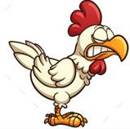 

Chicken boneless The chicken The human

 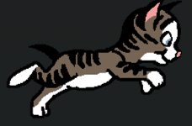

The dog The cat

## Environments

Dining room



## Equipment

## Cut scenes

The Chicken throws a bone at a cat scene.

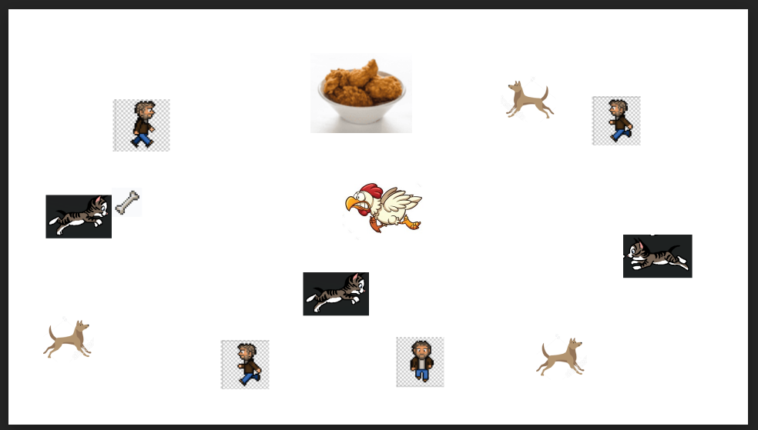

## Miscellaneous